Project Design Phase
Solution Architecture
Date | 05-Oct-2026
Team ID | SWTID-2026-4623
Project Name | AI BlogNest API
Maximum Marks
Solution Architecture:
The solution architecture bridges the business problem (slow, unorganized and insecure blog workflows) and the technology solution (a layered, AI-assisted REST API). Its goals are to:
- Find the best technology solution for the content-management problems of creators.
- Describe the structure, behaviour and flow of the software to stakeholders.
- Define features, development phases and solution requirements.
- Provide the specifications by which the solution is defined, managed and delivered.
Solution Architecture Diagram:
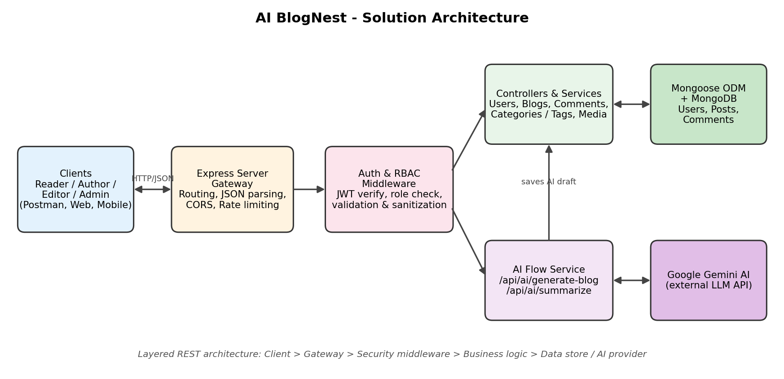
Figure 1: Architecture and data flow of AI BlogNest
Components:
Component | Responsibility
Client / Interface | Postman or front-end apps send HTTP requests and receive JSON for the Reader, Author, Editor and Admin roles.
Express Server Gateway | Listens on the network port, maps GET, POST, PUT and DELETE routes, parses JSON payloads and handles CORS.
Auth and Role Middleware | Extracts and verifies the JWT, checks the user's role against the route's required permission, validates and sanitizes input.
Controllers and Services | Apply business rules for blog lifecycle (Draft, Pending Approval, Scheduled, Published), comments, categories, tags and media metadata.
AI Flow Service | Exposes /api/ai/generate-blog and /api/ai/summarize, builds prompts and calls Google Gemini for generation and summarization.
Database Layer | Mongoose schemas and models translate application logic to MongoDB queries for users, posts and comments.
Technology Stack:
- Runtime and framework: Node.js (v16+), Express.js
- Database: MongoDB with Mongoose ODM
- Security: JWT, bcrypt.js, role-based access control, input sanitization, rate limiting
- AI: Google Gemini
- Testing: Postman / ThunderClient; pattern: MVC with a routing layer in place of views

